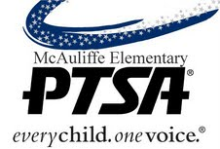

October 4, 2019

Christa McAuliffe PTSA 2.8.36
EIN: 91-1492758
23823 NE 22nd Street
Sammamish, WA 98074

To: ___ ______________________________________

Donation Amount: $ ________________________

Christa McAuliffe PTSA appreciates your generous donation in support of the Fun Run on October 4th, 2019. Your donation will be used to fund programs like Art Start, School Assemblies, Accelerated Reading, 5th Grade Outdoor Education, the School Play, and much more.

This is your receipt. It acknowledges that no goods or services were given to you in exchange for your contribution. The amount of your donation is tax-deductible as a charitable contribution to a Washington State corporation organized under the federal 501(c)(3) tax code.

Thank you for your donation.

Sandy Jameson
Treasurer
Christa McAuliffe PTSA

Please retain this document for your federal income tax records.

